**Iterative model:**

The iterative process model is a software development life cycle (SDLC) approach in which the initial development work is conducted based on initial requirements that are clearly defined, and subsequent features are added to this base software product through iterations until the final system is completed

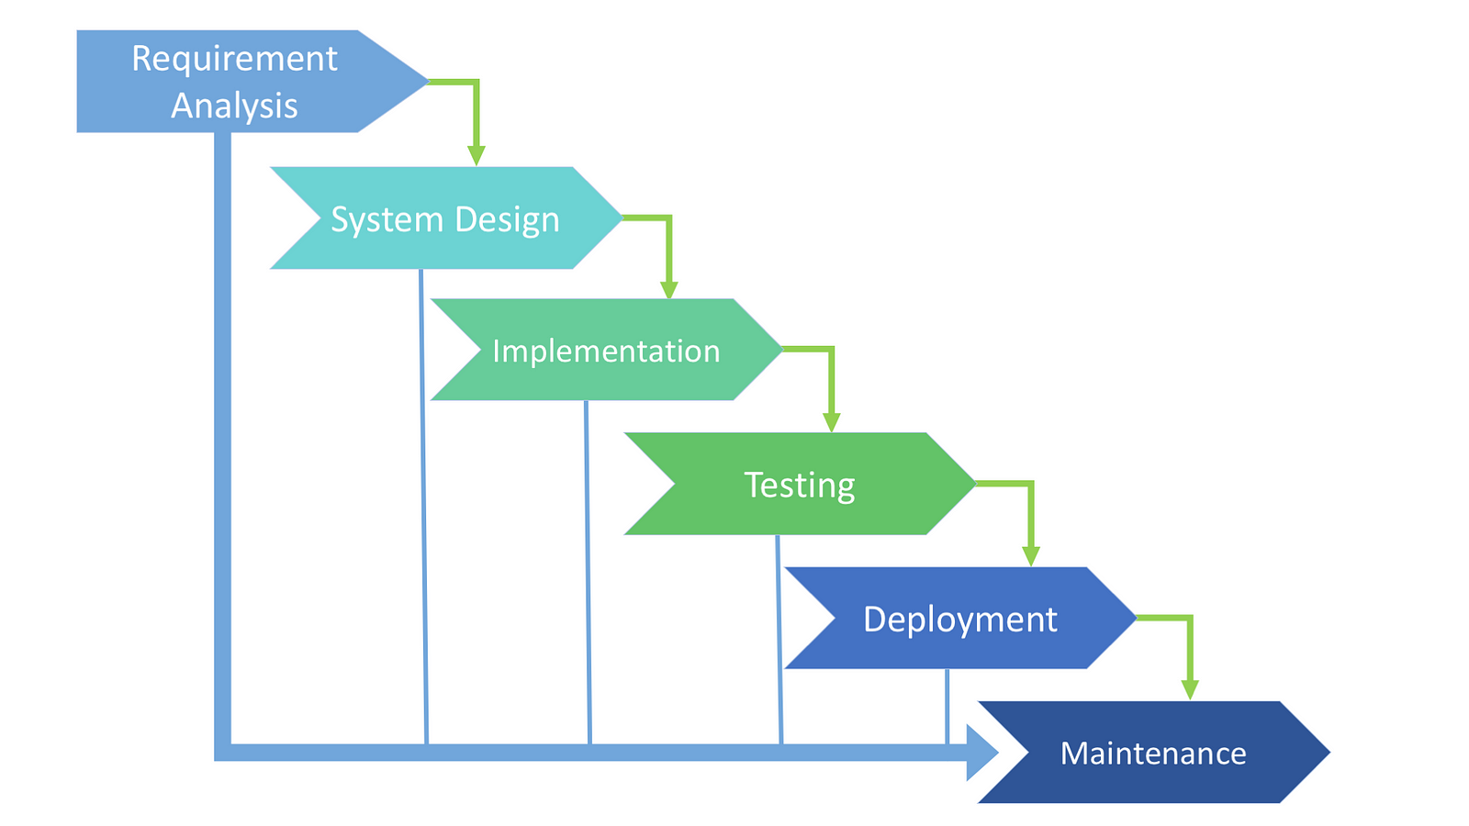

**Uses:**

* when requirements are cleared
* when requirements re easy to understand.
* If projects has frequently requirement changes
* If the software product is large.

**Advantage:**

* Easily acceptable change requirements
* Risks identifies at early stages
* Less time spent in documentation
* Some workinh features can be developed rapidly in the early stage.

**Disadvantages**:

* Not suitable for small types of projects
* Due to change requirements,the deadline cannot be confirmed.
* Sometimes more budget is required due to requirement change frequently.
* Required more resources
* Highly skilled resources required